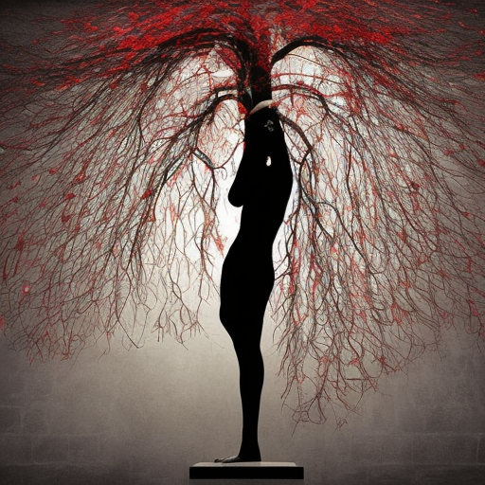
TREE OF FAUST

Towering intellects beckon triumph
Genius points beyond heroes
Minds languish in black boxes
Still, the fragrance of lilies
Steals freedom from frays
Sensual captivation for sale in every direction
The will to power’s busyness slays worlds
It presses wines of scarlet indulgence
Passionate love all night this ecstasy returns
Until Sorrow digs roots in Soils of Supreme Activity

